SWIRLY: Trick or treat!
Pumpkins are all over around so it's a sign that the ghosts, skulls and vampires time is coming: Halloween! Applications and games developers add spooky touches to their software so did the SWIRLY game indiedev but in a funny way.

29.10.2015
SWIRLY: Trick or treat!
http://www.creamsoft.com/mobile/swirly/
Pumpkins are all over around so it's a sign that the ghosts, skulls and vampires time is coming: Halloween! Applications and games developers add spooky touches to their software so did the SWIRLY game indiedev but in a funny way.
Do you really want to be scared ;-) ?
Swirly is a small, simple casual game in which you just need to release and drop a dot, a piece of pizza, balls, candies, brains (sic!) or other shapes in a specified color on a rotating „wheel” at just the right time and match the color or the shape. In the today's update the „wheel” is Halloween themed as well as the background, climatic music and sounds that may all together cause anxiety. And that's what this all about, to be a little scared, isn't?

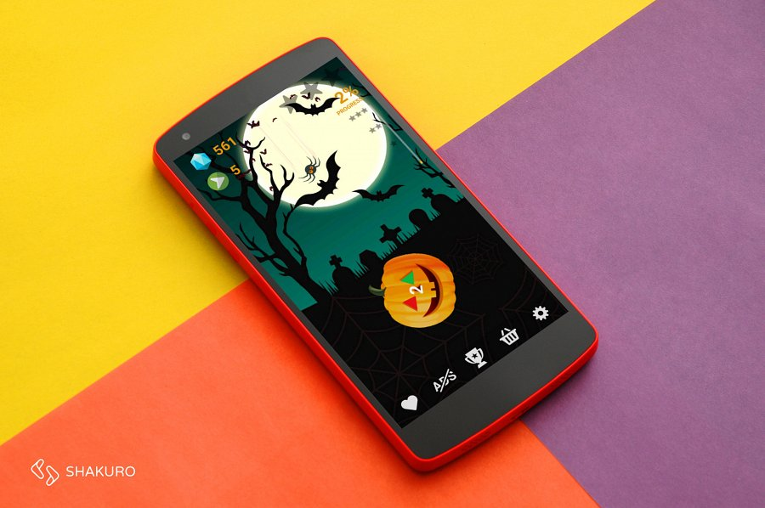
At the start we must win the easiest challenge: „skull”. Next a funny pumpkin which you have to hit with a spider, a zombie head or an eyeball. Next levels are harder as there are more items to throw. The game seems to be incredibly easy to play, but it is not so simple to win.
Why it is now even more addictive?
Halloween isn't the only new feature of the latest version. Another is probably even more interesting because it allows multiuser competition thanks to the new leader boards introduced in this version. It's not one of these annoying leader boards from Google Play Game Services, GameCenter or similar that we know from other games, but the developer's own solution. Players on different operating systems may now compete in one common leader board where the user's device OS is marked with an icon. So Android users may compete against Windows Phoners (iOS version coming soon) or residents of one country may want to make the leader board owned by their nationality. As the author says: „It may be difficult for Android players to win the board because there are more than 5 times more Windows Phone players of the Swirly game. Nevertheless I wish all of them luck!”.

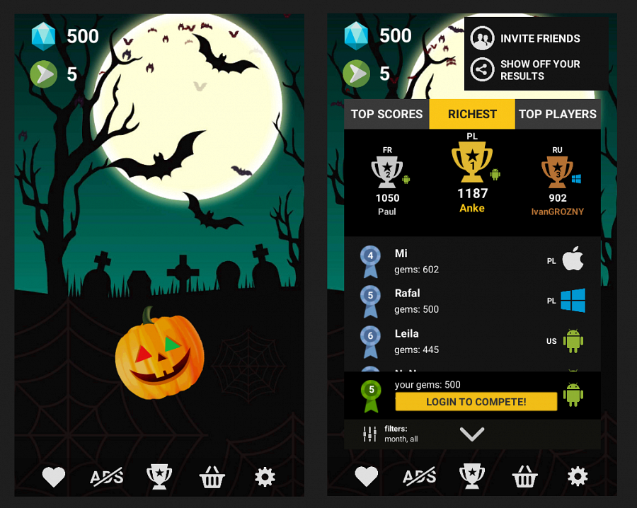
The game is free but shows ads that you can of course disable by in-app purchase. However, on Android devices the ads are part of the game and you can help yourself and rescue your stage or earn gems by watching rewarded video ads.
It is also worth mentioning that the game is translated to 16 different languages.
For a better start
The developer prepared a gift for our readers so that we can now share a set of coupons for free gems that players can enter in the game to get 3000 jewels. Players may then use the gems to unlock new levels or items that are available in the freeplay mode. Below is a picture that shows how to enter the coupons. A single coupon may be used only once.

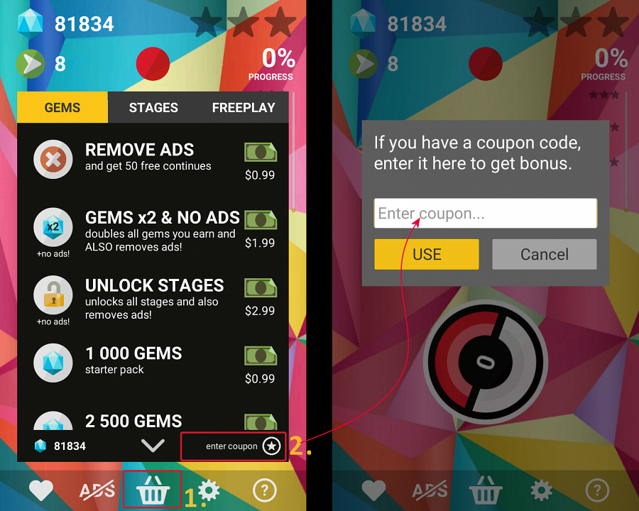

Platforms and operating systems
Windows Phone 8, 8.1, 10
Android 4+

Store URL:
Android Goole Play
https://play.google.com/store/apps/details?id=com.creamsoft.swirly
Windows Phone:
http://www.windowsphone.com/s?appid=96324ee0-a837-4028-b86a-eda2cdaa0dc7

Homepage:
http://www.creamsoft.com/mobile/swirly/
Price:
free with in-app purchases and ads
Languages:
English, German, Dutch, French, Finnish, Greek, Spanish, Portuguese, Chinese, Japanese, Korean, Polish, Ukrainian, Russian, Croatian, Italian
Developer:
Rafal Platek (cream.software)

